|  |  |
| --- | --- |
|  | **FIRST**  **NAME:…………Ansar………………………………** |
| **This question paper must be returned. Candidates are not permitted to remove any part of it from the examination form** | **LAST**  **NAME: …Amrin…………………………………….** |
|  |  |
|  | **STUDENT NUMBER:……19B030630……………………………………..** |

**ENDTERM EXAMINATION - APRIL 2020**

**EXAMINATION DETAIL**

|  |  |
| --- | --- |
| **Unit Code:** | STAT 2201 |
| **Unit Name:** | Statistics, Probability and Statistics |
| **Duration of exam( incl. reading time if applicable):** | 2 hrs (100 min) plus 10 mins reading time |
| **Total no. of questions:** | 5 |
| **Total no. of pages (incl. this cover sheet)** | 5 |

**INSTRUCTIONS:**

**1.Answer all sections.**

**2.All questions should be answered on the examination paper.**

**3.Writing must be eligible and answers clearly set out.**

**MidTerm Exam total: 15 marks according to Syllabus of the course.**

**MATERIALS PERMITTED/NOT PERMITTED:**

Distribution Tables: No dictionaries permitted.

Calculations: Permitted.

General Formulas: Permitted.

Lecturer Bissembayev Alibek, Phd

Dean of FIT ____________________

Discussed at the departmental meeting «22» 04. 2020, the report № .

**Question 1**

**[3 marks]**

Suppose that a certain drug A was administered to eight patients selected at random, and after a fixed time period, the concentration of the drug in certain body cells of each patient was measured in appropriate units. Suppose that these concentrations for the eight patients were found to be as follows:

1.23, 1.42, 1.41, 1.62, 1.55, 1.51, 1.60, and 1.76.

Suppose also that a second drug B was administered to six different patients selected at random, and when the concentration of drug B was measured in a similar way for these six patients, the results were as follows:

1.76, 1.41, 1.87, 1.49, 1.67, and 1.81.

Assuming that all the observations have a normal distribution with a common unknown variance, test the following hypotheses at the level of significance 0.05: The null hypothesis is that the mean concentration of drug A among all patients is at least as large as the mean concentration of drug B. The alternative hypothesis is that the mean concentration of drug B is larger than that of drug A.

SOLUTION 1:

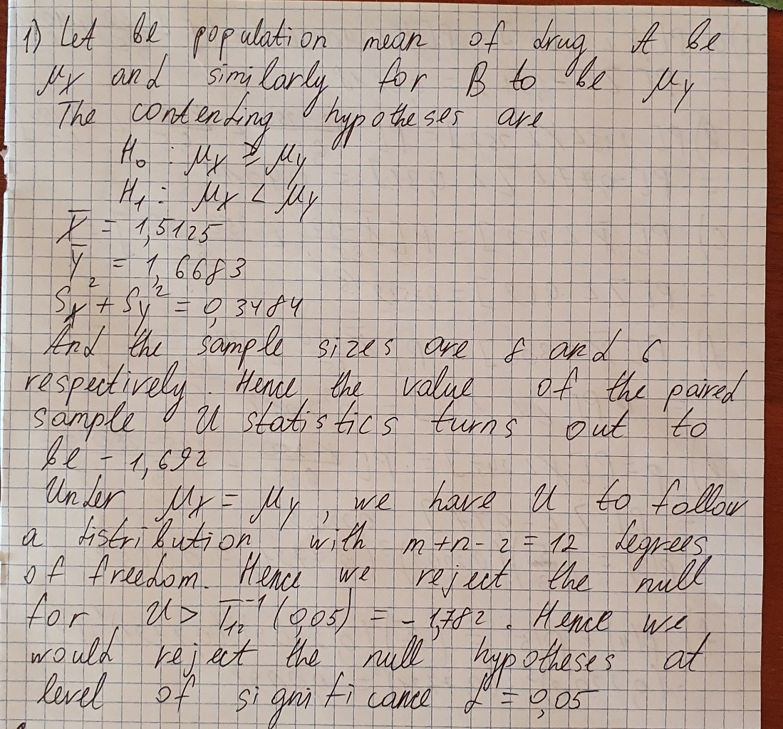

**Question 2**

**[3 marks]**

Let *X* be the time it takes a runner to complete a 1500 meter race. It is known that for this specific runner, the random variable *X* has a normal distribution with mean μ = 250.0 seconds and standard deviation = 6.5 seconds. Compute the probability that:

a) The runner completes his next 1500 meter race in under 4 minutes.

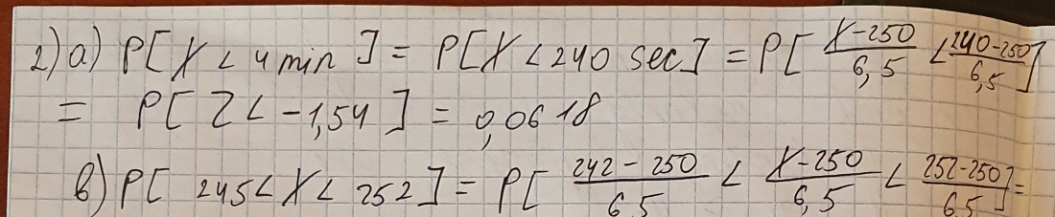

b) The runner takes between 245 and 252 seconds to complete his next 1500 meter race.

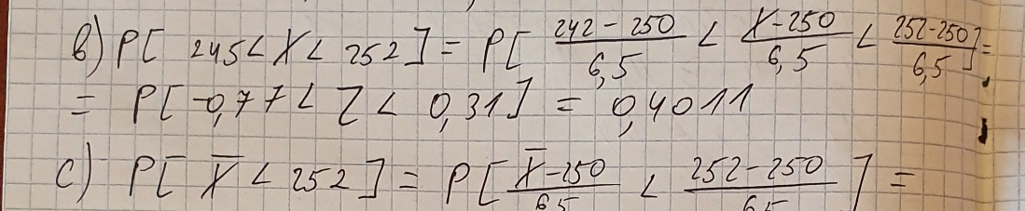

c) In the next n = 5 races the runner's average time to complete the race is under 252 seconds.

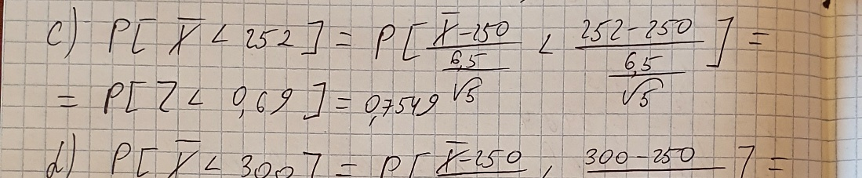

d) In the next n = 3 races the runner's average time to complete the race is under 300 seconds.

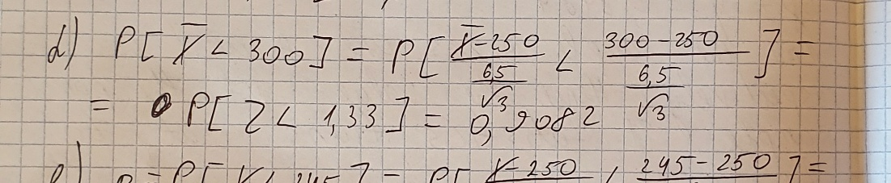

e) In the next n = 5 races, the runner beats the time of 245 seconds exactly 3 times.

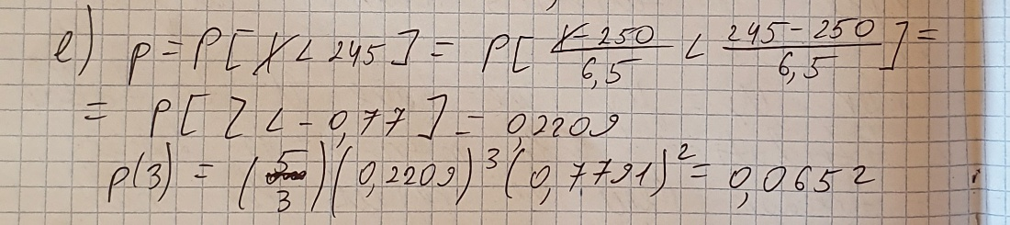

f) In the next n = 5 races, the runner beats the time of 245 seconds at least 4 times.

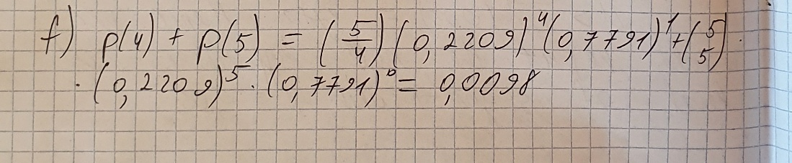

**Question 3**

**[3 marks]**

Suppose that in a problem of simple linear regression, the 10 pairs of observed values of *xi* and *yi* given in Table are obtained.

***i***

1 0.3 0.4

2 1.4 0.9

3 1.0 0.4

4 -0.3 -0.3

5 -0.2 0.3

6 1.0 0.8

7 2.0 0.7

8 -1.0 -0.4

9 -0.7 -0.2

10 0.7 0.7

**a.** Test the following hypotheses at the level of significance 0.01:

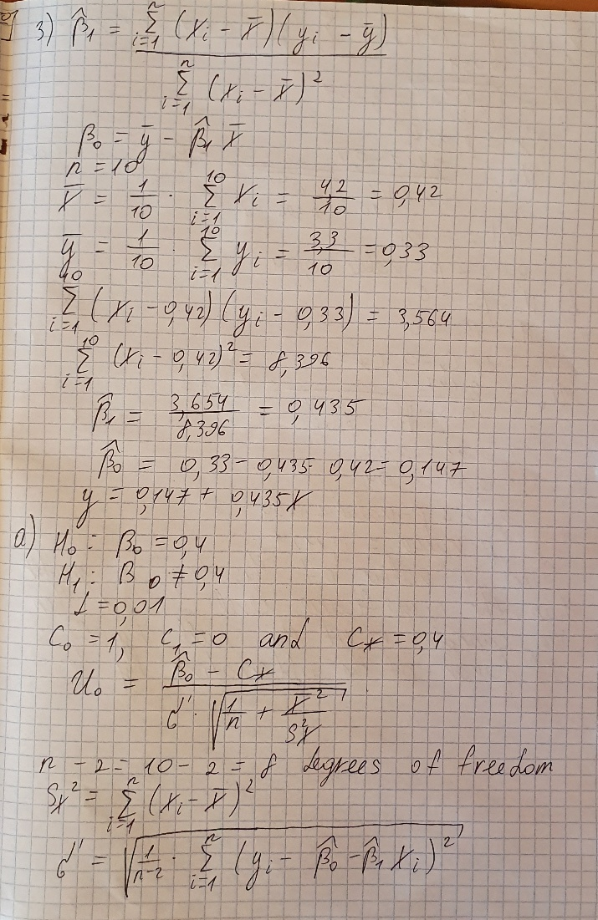

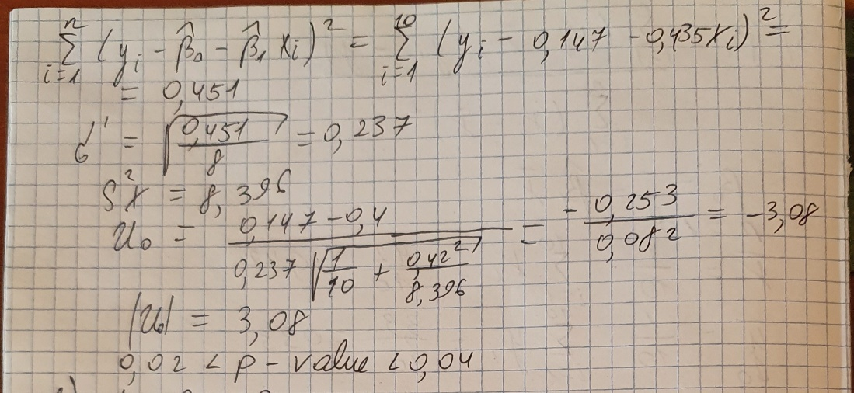

**b.** For the data presented in Table, test at the level of significance 0.01 the hypothesis that the regression line passes through the origin in the xy-plane;

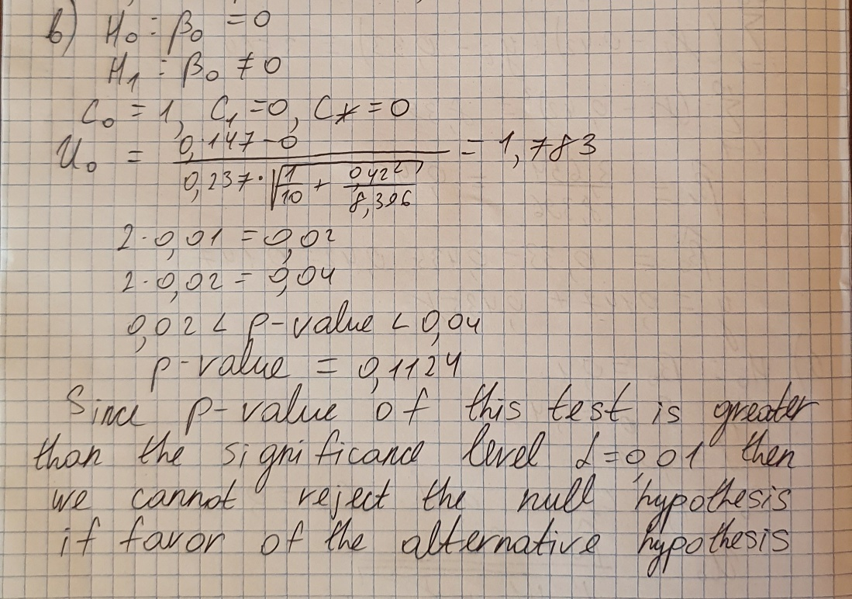

**c.** For the data presented in Table, sketch a confidence band in the xy-plane for the regression line with confidence coefficient 0.95;

**d.** On the same graph, sketch the curves which specify the limits at each point x of a confidence interval with confidence coefficient 0.95 for the value of the regression line at the point x;

**e.** Construct a confidence interval for 5β0 − β1+ 4 with confidence coefficient 0.90;

**f.** For the data presented in Table 11.9, construct a confidence interval with confidence coefficient 0.99 for the height of the regression line at the point x = 0.42.

**Question 4**

**[3 marks]**

In 1973, the President of Texaco, Inc., made a statement to a U.S. Senate subcommittee concerned with air and water pollution. The committee was concerned with, among other things, the noise levels associated with automobile filters. He cited the data in Table from a study that included vehicles of three different sizes.

**Vehicle size Noise values**

Small 810, 820, 820, 835, 835, 835

Medium 840, 840, 840, 845, 855, 850

Large 785, 790, 785, 760, 760, 770

**a.** Construct the ANOVA table for these data;

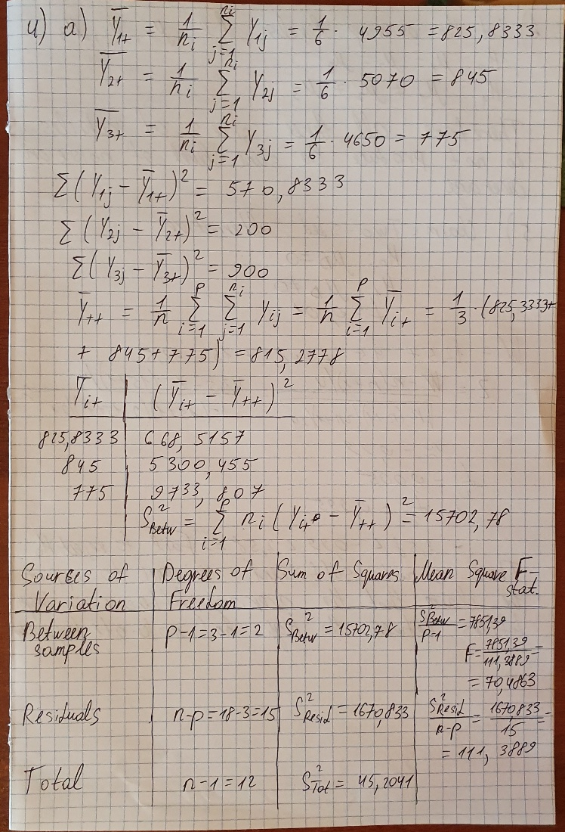

**b.** Compute the p-value for the null hypothesis that all three sizes of vehicles produce the same level of noise on average.

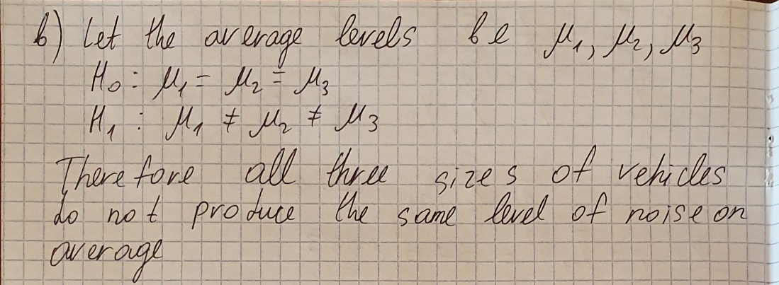

**Question 5**

**[3 marks]**

Two manufacturing processes are available for annealing a certain kind of copper tubing, the primary difference being in the temperature required. The critical response variable is the resulting tensile strength. To compare the methods, fifteen pieces of tubing were broken into pairs. One piece from each pair was randomly selected to be annealed at a moderate temperature, the other piece at a high temperature. The resulting tensile strengths (in tons/sq in.) are listed in the following table.

Analyze these data with a Wilcoxon signed rank test. Use a two-sided alternative. Let α = 0*.*01.

|  |  |  |
| --- | --- | --- |
| *Tensile Strengths (tons/sq in.)* | | |
| Pair | Moderate Temperature | High Temperature |
| 1 | 16.5 | 16.9 |
| 2 | 17.6 | 17.2 |
| 3 | 16.9 | 17.0 |
| 4 | 15.8 | 16.1 |
| 5 | 18.4 | 18.2 |
| 6 | 17.5 | 17.7 |
| 7 | 17.6 | 17.9 |
| 8 | 16.1 | 16.0 |
| 9 | 16.8 | 17.3 |
| 10 | 15.8 | 16.1 |
| 11 | 16.8 | 16.5 |
| 12 | 17.3 | 17.6 |
| 13 | 18.1 | 18.4 |
| 14 | 17.9 | 17.2 |
| 15 | 16.4 | 16.5 |

SOLUTION 5:

